**DAY 15**

QUESTION 1 (DATABASE DIAGRAM)

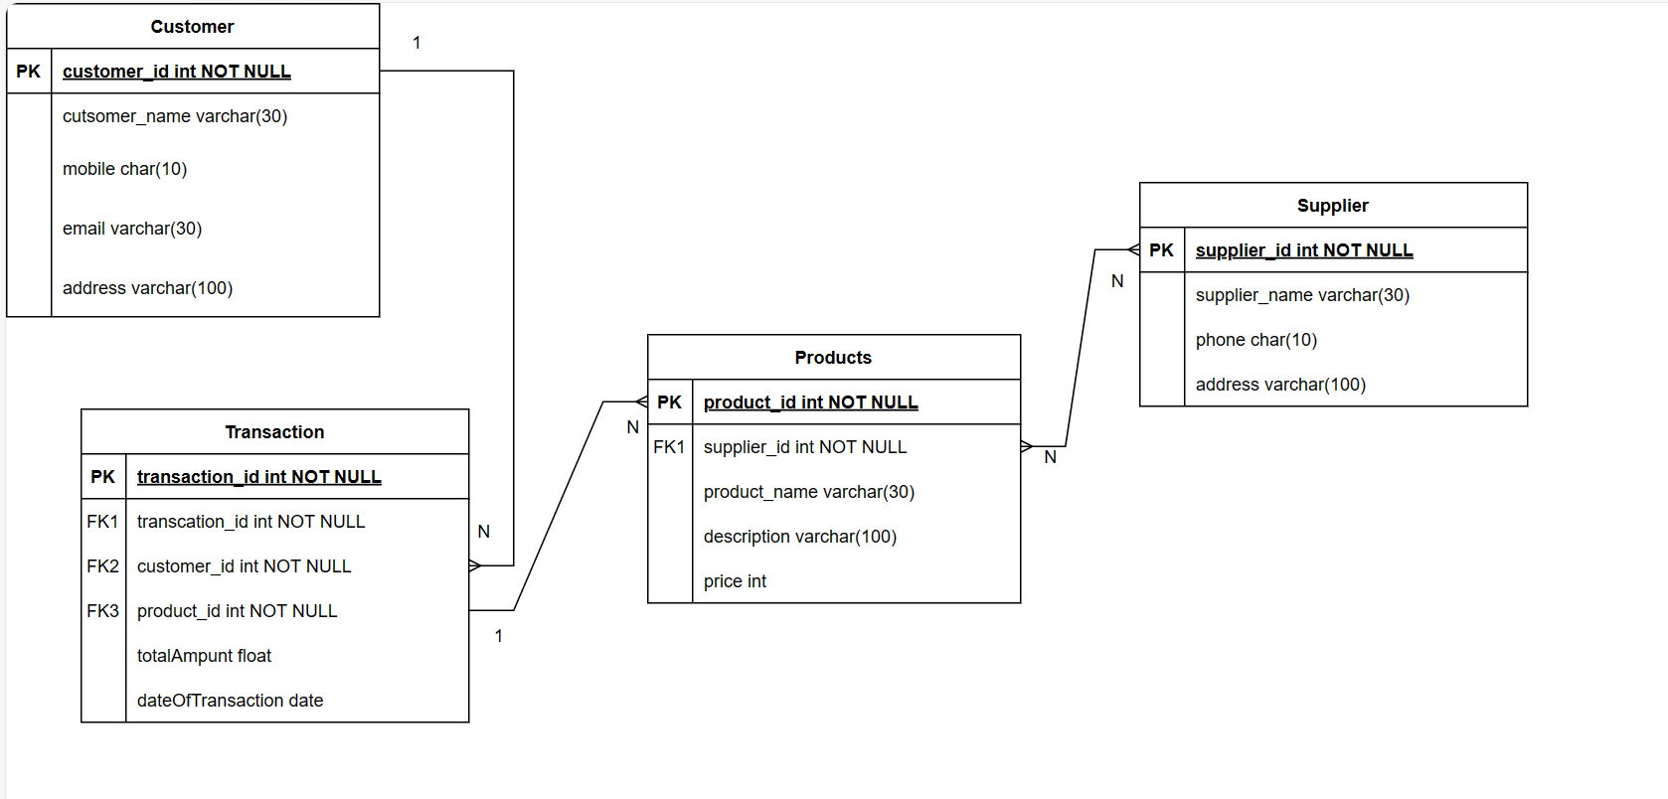

QUESTION 1 (ER DIAGRAM)

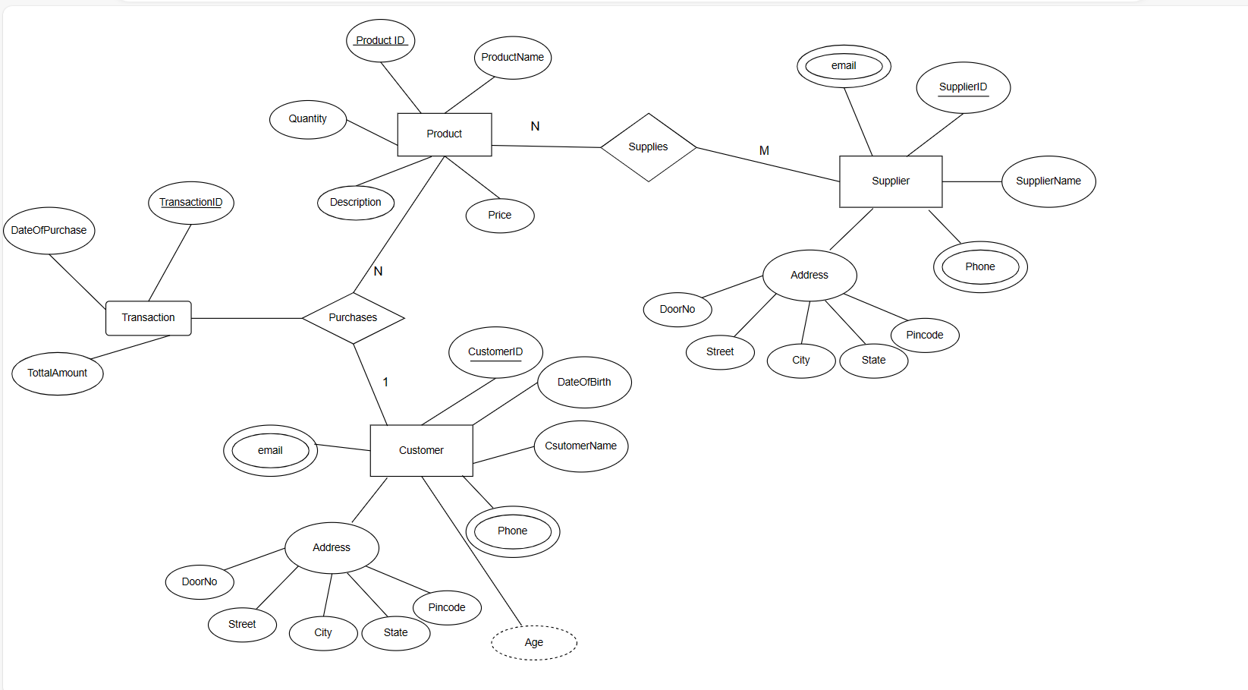

QUESTION 2 (ER DIAGRAM)

